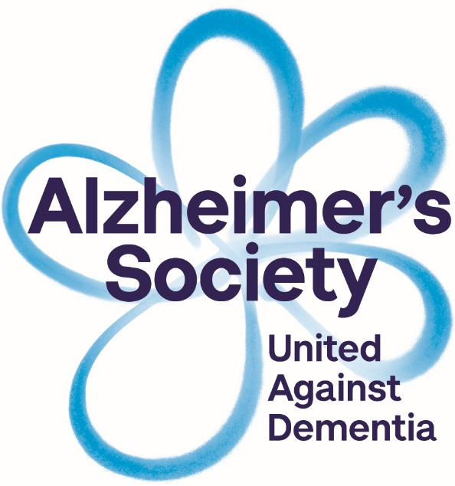

**Are you worried about your**

**memory?**

Join us for a free

**Memory Information Session**

at

Chesham Methodist Church  
Bellingdon Road, Chesham, HP5 2HA

**Tuesday 20th November, 10.30 – 12.30.**



The session will last for two hours and will include:

Understanding Memory

Memory Tips

Coping Strategies

Access to a wide range of information

Signposting to other services and organisations

**For more information or call Memory Support on**

**01296 331749**

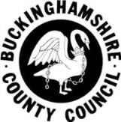 [**memorysupport@alzheimers.org.uk**](mailto:memorysupport@alzheimers.org.uk)

Registered charity number 296645